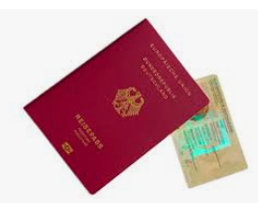
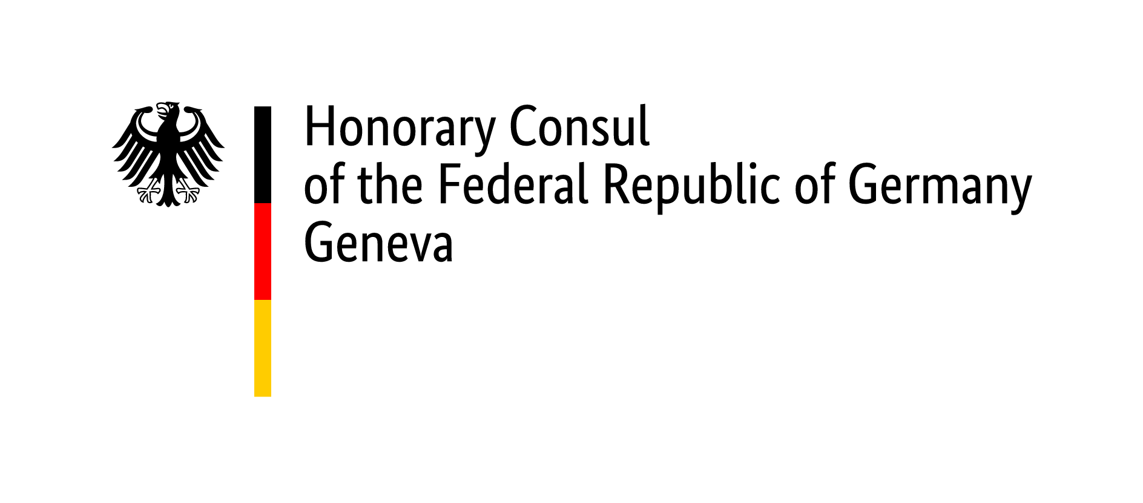

Checklist for passport/ ID card application (minors)

Minors have to appear together with their legal guardians. If a parent with custody is not able to come to the appointment, the parent's certified declaration of consent has to be brought along. Minors from the age of 16 can only apply for an ID card on their own.
If you are applying for the first time, please read the information on Birth of a child abroad. Information from Swiss birth certificates do not always automatically apply to German law. If necessary, please have the legal situation clarified before making an appointment!

The following documents are always required:

- Duly completed application form.
(If a passport and an ID card are requested at the same time, one form is required for each.)
- One recent valid biometric passport picture (max. 6 months old) ( photo sample board of the Federal printing office )
- Last identity document of the child (in original and a copy of the data page of the passport or the front and back of the ID card. If the identity document was lost or stolen, a police report is required.)
- Passports or ID cards of both parents (original with copy)
- Residence permit for Switzerland or Swiss passport/ID-Card of the child and the parents (original with copy)
- Proof of current address of the child and the parents (e.g., electricity bill or similar)

Additional documents to be submitted (if applicable, always in original and with a copy), if:
- the passport or identity card was not issued by the German Embassy in Bern or
- issued before 2010 or
- there have been changes since the last application in Bern

- If the address in your last passport is still a German residence: proof of deregistration
("Abmeldebestätigung”)
- Birth/parentage certificate of the child (German, alternatively issued by the country of birth) (Note: If the child was born in Germany after 31 December 1999 to two foreign parents, a birth certificate is not sufficient; an extract from the German birth register is always required)
- Marriage certificate of the parents or Excerpt of the family register with declaration of name choice and, if applicable, certification of the name according to German law
- If the parents were not married at the time of the birth of the child, Custody agreement according to the law of the country of residence or Declaration on custody
- For minors whose parents are divorced and when only one parent has custody, Proof of sole custody by decision of a judge or a copy of the divorce decree. A divorce abroad requires recognition in Germany.
- For children (at the time of birth) of unmarried parents, if made:
Declaration of acknowledgement of paternity, in the case of acknowledgement in Switzerland and, if applicable, declaration of consent of the child's mother.
- Proof of German citizenship (certificate of declaration or naturalisation, only if born abroad and/or without a German parent)
- Proof of acquisition of another nationality (naturalisation certificate, civil status form 7.9 - proof of citizenship for Swiss nationals)

Documents in foreign languages (other than English or a national language) must be translated. In individual cases, the presentation of additional certificates and documents may be required and, if necessary, also an apostille or legalisation of foreign documents may be necessary, especially when applying for a German passport for the first time.

General information

- Pay attention to the validity of travel documents and try to renew them well in advance!
- It is not possible to extend the validity of a passport or an ID card.
- To apply for identity documents, both parents/all legal guardians must be present in person with the child to have their electronic fingerprints taken (from the age of 6). Applications received by post cannot be processed.
- If you live in Switzerland or the Principality of Liechtenstein and are deregistered in Germany, the German Embassy in Bern is the passport and ID authority responsible for you. You can also apply at an office of the honorary consuls in Zurich, Basel, Geneva, Lugano or Balzers (Liechtenstein), in which case the processing time will be two to three weeks longer.
- Once the application is complete, the processing time takes approximately six weeks, during peak travel season it takes closer to eight weeks. The express procedure takes two to three weeks. Your biometric passport will be produced at the Bundesdruckerei in Berlin; it is not possible to influence this.
- A passport application can only be submitted if you make an appointment. Please contact us through our website www.deutscher-honorarkonsul-genf.ch .
- A photo booth is available in the waiting area (costs CHF 15). The machine is not suitable for children under the age of 6.
- Does your child have a surname under German law? Please clarify whether a
declaration of name and/or recognition of divorce is required in advance in your case.

Passport fees & important information

The fees must be paid at the time of application. You can pay these in cash in Swiss francs at the current exchange rate at the Geneva office or by debit card or Postcard (no credit cards).

Passport
(biometric, from 6 years onwards with fingerprints) processing time about 8 – 10 weeks
For applicants under 24, validity 6 years approx. CHF 66. – (depending on exchange rate)
Additional express processing fee approx. CHF 31. – (depending on exchange rate)

ID-Card
(biometric, from 6 years onwards with fingerprints) processing time about 6 - 8 weeks
For applicants under 24, validity 6 years approx. CHF 51, -- (depending on exchange rate)

Temporary passport (only in emergencies)
(machine-readable, not biometric, valid for 1 year) approx. CHF 67. – (depending on exchange rate)
If the application is submitted via an Honorary Consul's office, additional processing fees of
around CHF 81 (depending on the exchange rate) plus around CHF 20 (depending on the
exchange rate) for further applications from the same person will be added to the fees
mentioned above.
If you are not deregistered and/or not residing in Switzerland, an additional fee of approximately CHF 36 applies.
After completion, the identity document will be sent to you. In addition to the passport/ID card fee, there is a postage fee of CHF 5.
Temporary passports and identity cards are not recognised by all countries for entry. Entry requirements for other countries can be found in the travel and safety information and in the "Safe travel" app.

If you have any questions, please contact us in advance: genf@hk-diplo.de

Office of the Honorary Consul of the Federal Republic of Germany How to reach us:
Rue de Moillebeau 49, 1209 Genf from Geneva main station Cornavin take TPG bus no. 3 - direction „Gardiol“– bus stop „Moillebeau“

Status 01/2024

