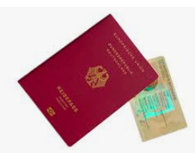

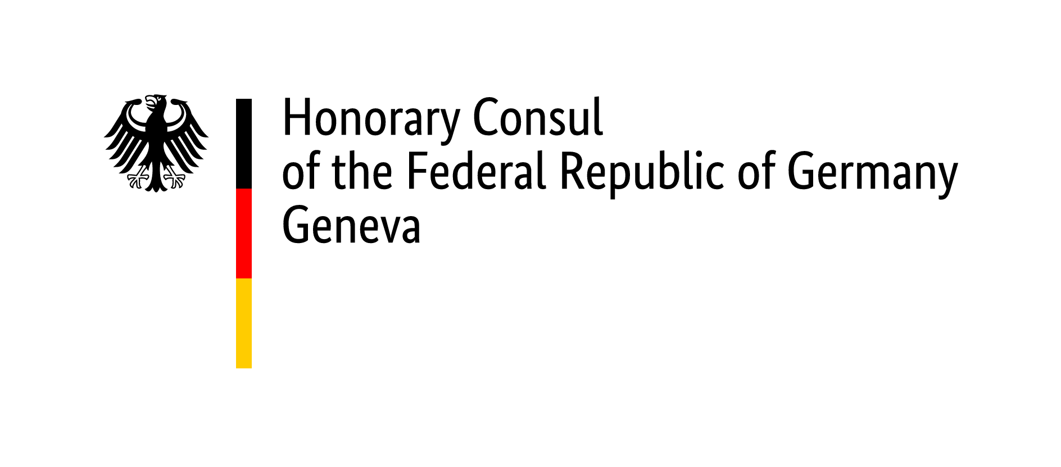

Checklist for passport/ID Card application (adults)

The following documents are always required:

- Duly completed application form.
(If a passport and an ID card are requested at the same time, one form is required for each.)
- One recent valid biometric passport picture (max. 6 months old). ( photo sample board of the Federal printing office )
- Last passport / temporary passport / ID card
Original and a copy of the data page of the passport or the front and back of the ID card.
If the identity document was lost or stolen (and was still valid), a police report is required.
- Residence permit for Switzerland or Swiss passport/ID card - original with copy

- Proof of current address (e.g., electricity bill or similar)
Additional documents to be submitted (if applicable, always in original and with a copy), if
- the passport or identity card was not issued by the German Embassy in Bern or
- issued before 2010 or
- there have been changes since the last application in Bern

- If the address in your last passport is still a German residence: proof of deregistration
("Abmeldebestätigung”)
- Birth/parentage certificate (German, alternatively issued by the country of birth) (Note: If the child was born in Germany after 31 December 1999 to two foreign parents, a birth certificate is not sufficient; an extract from the German birth register is always required)
- Swiss family certificate
- Proof of a name change (in case of marriage, partnership or after divorce)
- Proof of German citizenship (certificate of declaration or naturalisation, only if born abroad and/or without a German parent)
- Proof of acquisition of another nationality (naturalisation certificate, civil status form 7.9 - proof of citizenship for Swiss nationals)
- PhD certificate (in German or English, with full name and date of birth), if the applicant wishes the academic title to be mentioned in his new identity document and it did not appear in the previous one.

Documents in foreign languages (other than English or a national language) must be trans-lated. In individual cases, the presentation of additional certificates and documents may be required and, if necessary, also an apostille or legalisation of foreign documents may be necessary, especially when applying for a German passport for the first time.
If you are applying for a passport/identity card for the first time, please read the
information of name choice. The name on a foreign birth certificate, including a
Swiss birth certificate is not always automatically your name under German law.

General information

- Pay attention to the validity of travel documents and try to renew them well in advance!
- It is not possible to extend the validity of a passport or an ID card. To apply for identity documents, you have to be present in person to have your electronic fingerprints taken. Applications received by post cannot be processed.
- If you live in Switzerland or the Principality of Liechtenstein and you are deregistered in Germany, the German Embassy in Bern is the passport and ID authority responsible for you. You can also apply at an office of the honorary consuls in Zurich, Basel, Geneva, Lugano or Balzers (Liechtenstein), in which case the processing time will be two to three weeks longer.
- Once the application is complete, the processing time takes approximately six weeks, during peak travel season it takes closer to eight weeks. The express procedure takes two to three weeks. Your biometric passport will be produced at the Bundesdruckerei in Berlin; it is not possible to influence this.
- A passport application can only be submitted if you make an appointment. Please contact us through our website www.deutscher-honorarkonsul-genf.ch .
- A photo booth is available in the waiting area (costs 15 CHF).
- Has your name changed after marriage or divorce? Is your name not recorded in a German civil status certificate? Please clarify in advance whether a name declaration and/or divorce recognition is required in your case.
- Do you have any doubts as to whether you are in possession of German citizenship, which name you had under German law? Please have the legal situation clarified before making an appointment!

Passport fees & important information

The fees must be paid at the time of application. You can pay these in cash in Swiss francs at the current exchange rate at the Geneva office or by debit card or Postcard (no credit cards).

Passport (32 pages)
(biometric, from 6 years onwards with fingerprints) processing time about 8 – 10 weeks
For applicants under 24, validity 6 years approx. CHF 66. – (depending on exchange rate)
For applicants 24 years and older, validity 10 years approx. CHF 97. – (depending on exchange rate)
Additional fee for 48-page passport approx. CHF 21. – (depending on exchange rate)
Additional express processing fee approx. CHF 31. – (depending on exchange rate)

ID-Card
(biometric, from 6 years onwards with fingerprints) processing time about 6 - 8 weeks
For applicants under 24, validity 6 years approx. CHF 51, -- (depending on exchange rate)
For applicants 24 years and older, validity 10 years approx. CHF 64, -- (depending on exchange rate)

Temporary passport (only in emergencies)
(machine-readable, not biometric, valid for 1 year) approx. CHF 67. – (depending on exchange rate)
If the application is submitted via an Honorary Consul's office, additional processing fees of
around CHF 81 (depending on the exchange rate) plus around CHF 20 (depending on the
exchange rate) for further applications from the same person will be added to the fees
mentioned above.
If you are not deregistered and/or not residing in Switzerland, an additional fee of approximately CHF 36 applies.
After completion, the identity document will be sent to you. In addition to the passport/ID card fee, there is a postage fee of CHF 5.
Temporary passports and identity cards are not recognised by all countries for entry. Entry requirements for other countries can be found in the travel and safety information and in the "Safe travel" app.

If you have any questions, please contact us in advance: genf@hk-diplo.de
Office of the Honorary Consul of the Federal Republic of Germany How to reach us:
Rue de Moillebeau 49, 1209 Genf from Geneva main station Cornavin take TPG bus no. 3 - direction „Gardiol“– bus stop „Moillebeau“
Status 01/2024

