www.deutscher-honorarkonsul-genf.ch

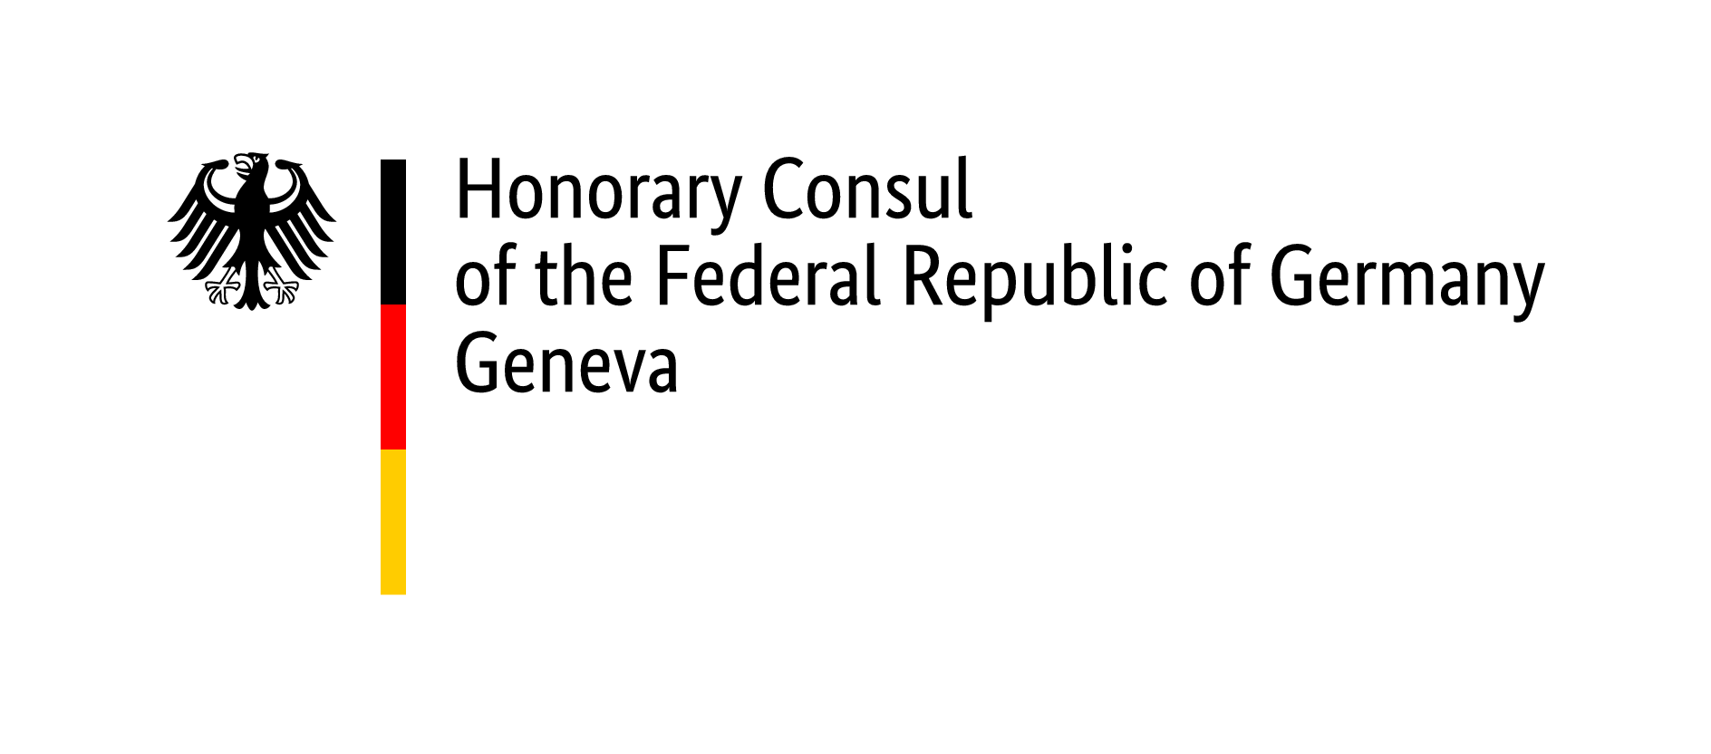

Checklist for passport/children’s passport/ID card application (under the age of 18)

Both parents / all legal guardians and the child must present at the consulate during the passport application. If a parent / legal guardian cannot be present, a separate consent form has to be certified (Zustimmungserklärung)
If you are applying for the first time, please note the information on name law and paternity acknowledgments, as well as information from Swiss birth certificates cannot be adopted for the German legal sphere in every case.

To bring along with the application

- Duly completed application form
If a passport and an ID are requested at the same time, one form is needed per request
- One recent valid biometric passport picture per application. Please refer to the passport picture template at https://www.bundesdruckerei.de/system/files/dokumente/pdf/Fotomustertafel-300dpi.pdf

All documents below must be submitted both in original (which will be returned) plus one copy. Please do not staple the copies together.

- Last identity document of the child
Please copy the biographical data page of the passport or the front and back of the ID card. If the identity document was lost or stolen, a police report is required.
- Passports or ID cards of both parents
- If the address in your last passport is still a German residence: proof of deregistration
("Abmeldebestätigung”)
- Residence permit of the child (if already available)
- Residence permit of both parents (if applicable) or proof of current address (e.g., electricity bill or similar), only if you do not have a residence permit or the current address is not stated in it.
- Birth certificate / certificate of origin of the child
An excerpt from the birth register is required if the minor was born in Germany after 1 January 2000 and none of the parents was a German citizen at the time of his birth.
- If parents are married: Marriage certificate of the parents or Excerpt of the family register with declaration of name choice. If the marriage of the parents took place abroad a name certificate in accordance with German law must be produced. More info at www.bern.diplo.de/namensrecht
- In addition, for minors whose parents are divorced and when only one parent has custody, Proof of sole custody by decision of a judge or a copy of the divorce decree. In case the divorce took place abroad, please consult the relevant guidelines: www.bern.diplo.de/scheidungsanerkennung
- If the parents were not married at the time of the birth of the child, an Acknowledgement of paternity in accordance with the German law is required. More information: www.bern.diplo.de/vaterschaftsanerkennung
- If the parents were not married at the time of the birth of the child,
if done: Custody agreement according to the law of the country of residence
if not made: Declaration on custody

In addition (if applicable):

- Act of acquisition of German citizenship by naturalization (ʺEinbürgerungsurkundeʺ).
- Act of acquisition of a foreign nationality (e.g. for the Swiss nationality, the certificate of origin issued by the canton). Presentation of the passport of the foreign nationality is not sufficient.

All foreign civil status documents not issued under the CIEC-convention must be stamped with an apostil or legalised.
Additional documents and certificates may be required

www.deutscher-honorarkonsul-genf.ch

General information

- It is not possible to extend the validity of a passport or an ID card.
- Both parents / all legal guardians and the child must present at the consulate during the passport application. Applications sent by post will be returned unprocessed to the sender.
- If the minor is no longer registered in Germany and lives in Switzerland or the Principality of Liechtenstein, the embassy in Bern is the competent authority to establish or renew his passport and/or ID card. As long as he resides in their respective jurisdictions, it is also possible to apply for a passport with the Honorary Consuls in Zurich, Basel, Geneva or Lugano.
- A passport application can only be submitted if you make an appointment. Please contact us through our website www.deutscher-honorarkonsul-genf.ch .
- Is the minor entitled to bear his parents' surname according to German law? Please inquire in advance by phone if a certificate of change of name and / or a copy of a divorce decree is required. Please also read the information note on the legislation on naming rights www.bern.diplo.de/ch-de/service/-/1435470, or respectively, on the recognition of divorce www.bern.diplo.de/ch-de/service/-/1435466.

Passport fees & important information

The fee is payable upon application. In the Geneva office the fees can be paid in Swiss francs in cash (Euros are not accepted) or with Maestro/V-Pay bank cards as well as Postcard. Payment by credit or debit card is only possible with a surcharge of 2%.
If the child are domiciled outside the district, for example in neighbouring France, or if the child’s residence is still registered in Germany, the fees will increase depending on the requested document.

Biometric passport (with fingerprints from the age of 6 years), processing time about 8 weeks
For applicants under 24, validity 6 years approx. CHF 70. – (depending on exchange rate)
Additional express processing fee (approx. 4 weeks) approx. CHF 40. – (depending on exchange rate)
Honorary Consul fee currently CHF 85. –
Fixed fee CHF 5. –

ID-Card (with fingerprints from the age of 6 years), processing time about 8-9 weeks
For applicants under 24, validity 6 years approx. CHF 65, -- (depending on exchange rate)
Honorary Consul fee currently CHF 85, -
Fixed fee CHF 5, --

Passport for children (machine readable withour fingerprints), processing time approx. 2-3 weeks
Valid for 1 year, but not beyond the 12th birthday approx. CHF 31. – (depending on exchange rate)
Honorary Consul fee currently CHF 85. –
Fixed fee CHF 5. –

Please read carefully the information on the conditions of entry into a foreign country for holders of German passports on the website of the Federal Ministry of Foreign Affairs at
www.auswaertiges-amt.de/de/ReiseUndSicherheit/reise-und-sicherheitshinweise.

Office of the Honorary Consul of the Federal Republic of Germany Appointment by phone:
Rue de Moillebeau 49 Tue 09:00 am - 1:00 pm
1209 Geneva Wed 09:00 am - 2:00 pm
Phone: 022 734 66 06
Email: genf@hk-diplo.de
Internet: www.deutscher-honorarkonsul-genf.ch

How to reach us: from Geneva main station Cornavin take TPG bus no. 3 - direction „Gardiol“ - bus stop „Moillebeau“

Stand 10/2021

